Test Document

# Environment Setup (Windows)

**Development requirement (IDE: Intellij/eclipse)**

* Install JDK 1.8 or above
* Install Android SDK
* Node.js
* Appium

**System Variable (Add the installation folder to the System Variable)**

* JAVA_HOME
* ANDROID_HOME
* PATH

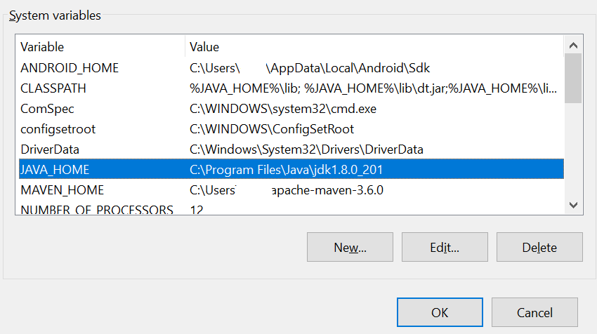

Check the environment by command line

>appium-doctor

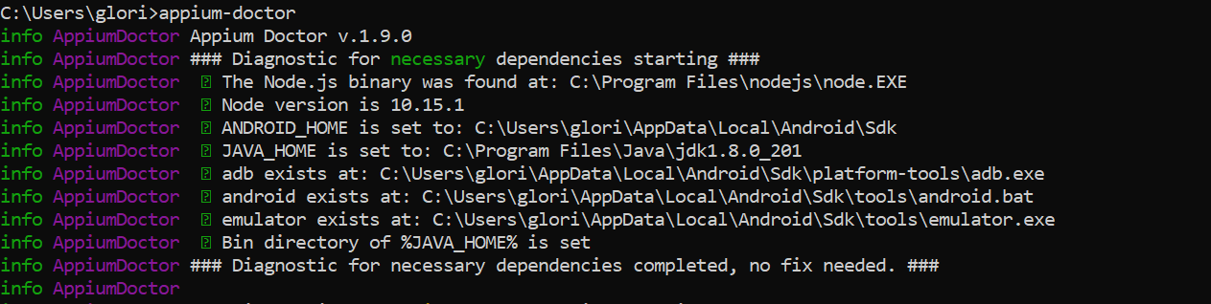

# Before Running the Test

Start the Appium Server in command line tool or desktop

>appium

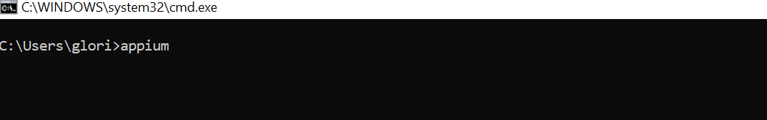

Click on Start Sever button

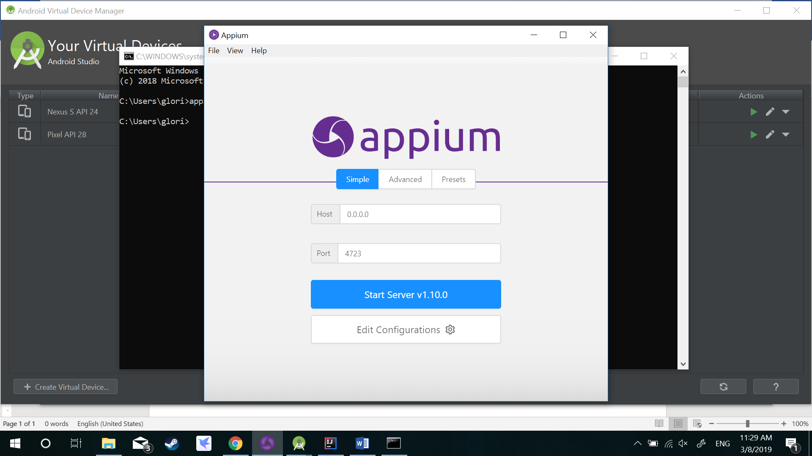

The Appium server will be up and running

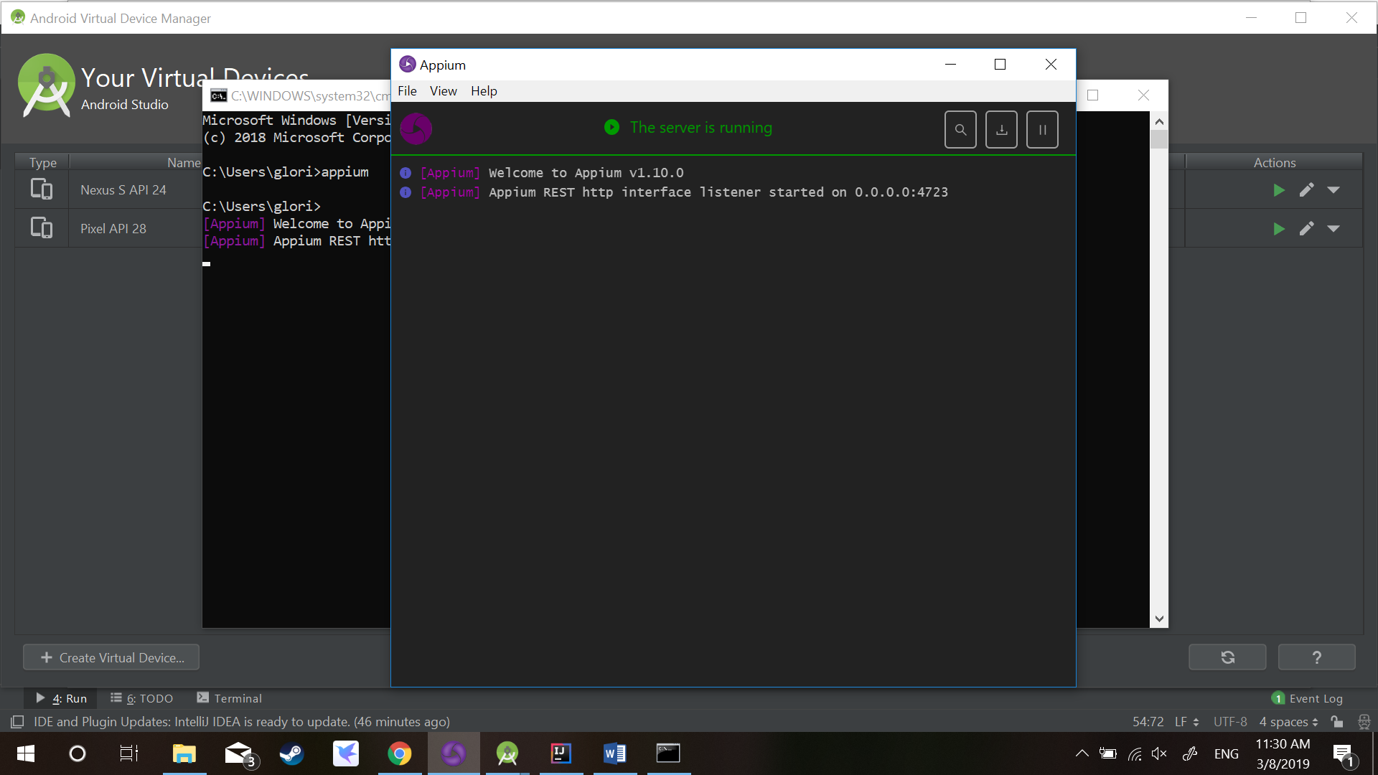

Start the AVD emulator with the desired API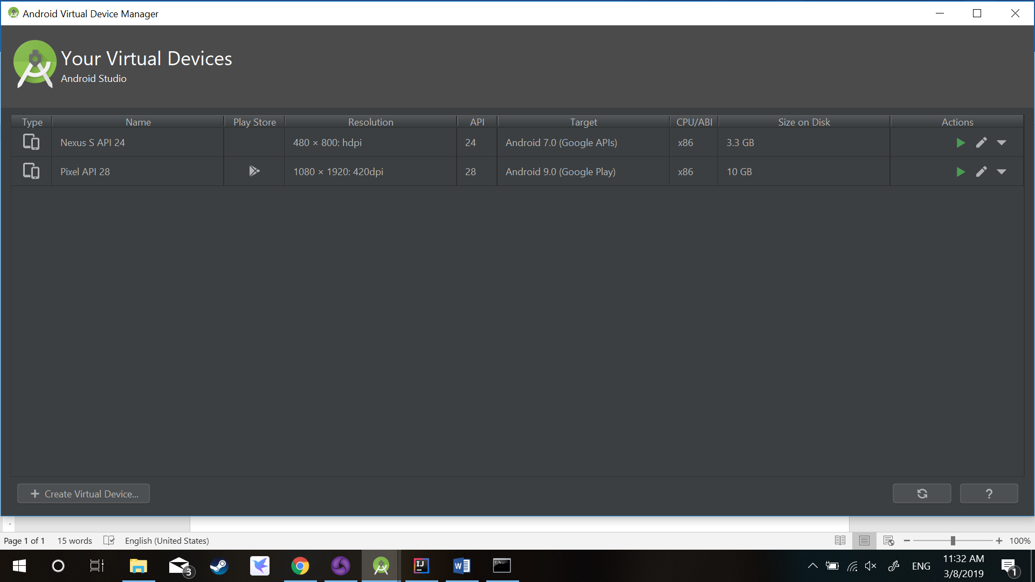

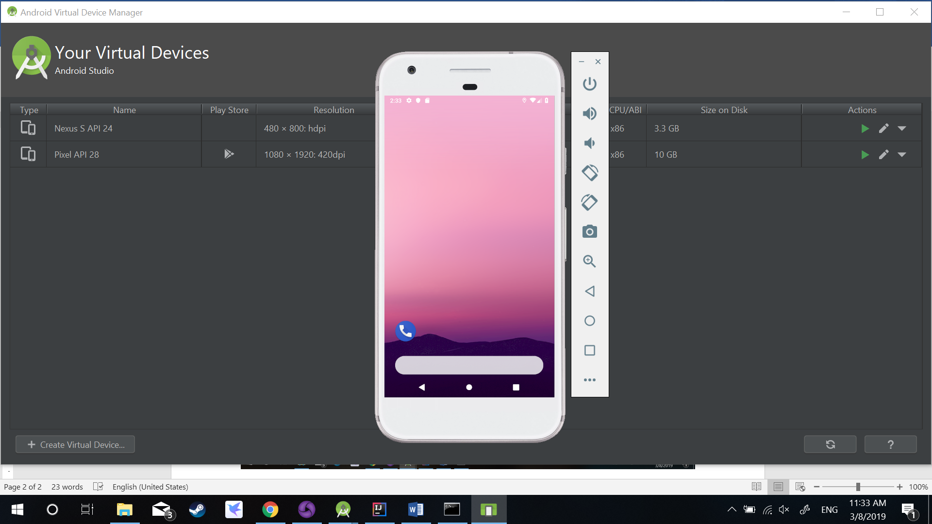

# Running the Test

Run by the IDE

– open Intellij and locate the Test xml, right click and run the test suite

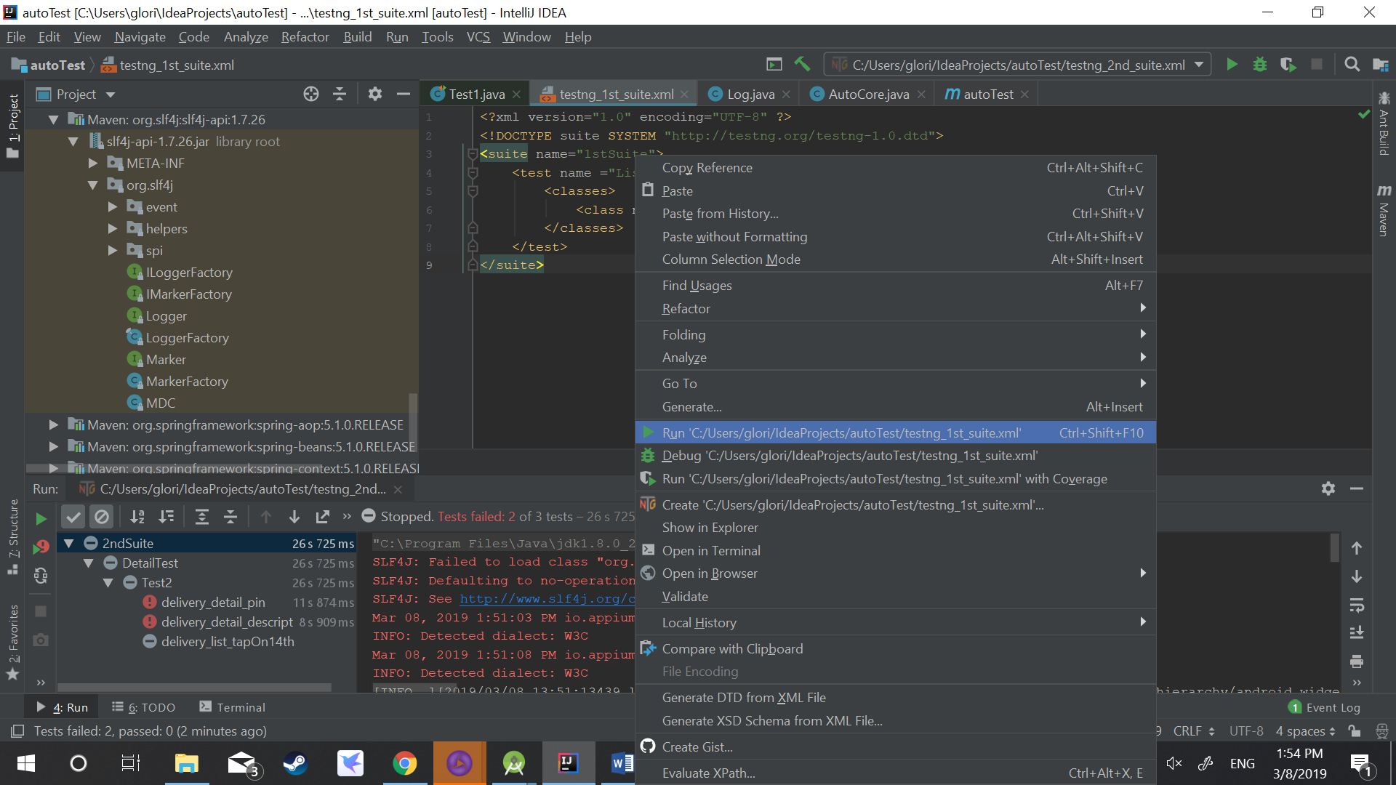

Run by command line – open CMD and input

>java -cp "C:\Users\glori\.m2\repository\org\testng\testng\6.14.3\testng-6.14.3.jar" org.testng.TestNG testng_1st_suite.xml

